**Kumbh Mela Celebration at Trimbakeshwar, India**

**September 2015**

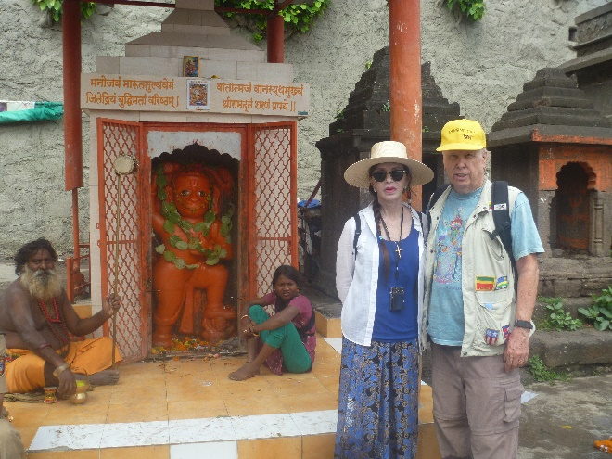

Kumbh Mela is celebrated at Trimbakeshwar in Nashik which is in Maharashtra. Trimbakeshwar is a holy town of Nasik as one of the twelve Jyotirlingas, Triyambakeshwar Jyotirlinga temple is situated there. Kumbh Mela in Nasik is celebrated once in every twelve years and is known as Sinhasta.

According to mythological stories and verses of epics the drops of Amrita or nectar fell at the Godavari River in Nasik when Lord Vishnu flew from earth to heaven after Samudra Manthan. That is the reason why the place is considered sacred and is of great importance amongst Hindus. In the lunar month of Magh when Sun and Jupiter are in Leo (Singh Rashi) zodiac sign Kumbh Mela is held at Trimbakeshwar in Nasik. The fair is celebrated with full passion and keenness in Nasik as one can evidence and about millions of pilgrims come here to wash away their sins in the holy river, Godavari. The two bathing ghats, Ramkund and Kushavarta holy reservoirs appreciate faith and belief of thousands of sadhus, holy men and millions of pilgrims as they take dips in holy River Godavari on the specific date and at specific time. As the administration is aware of the dates they start arranging accommodation facilities for the pilgrims who comes from all walks of life. The panorama of this festive season is worth watching.

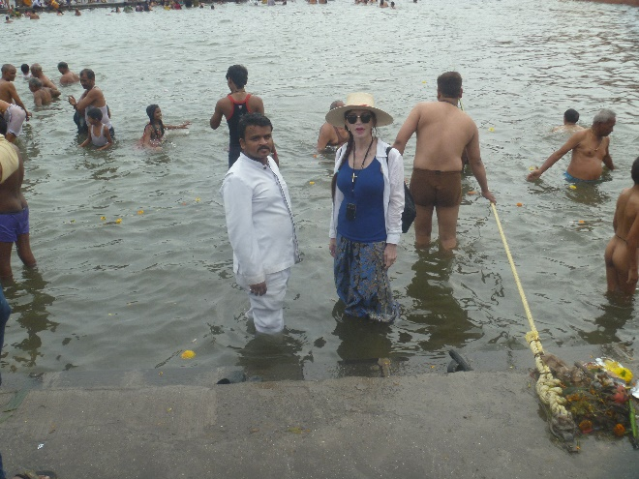

Victoria having her sins washed away in the Godavari River

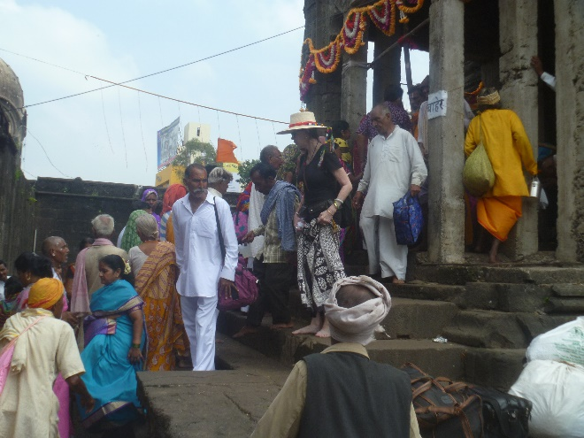

Naroshankar Temple, located right in the Godavari River, one of many temples we visited

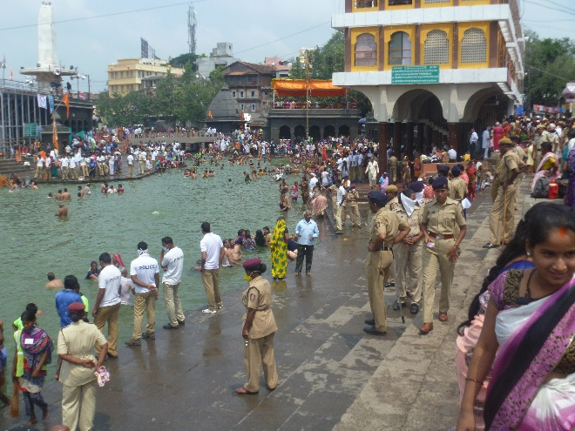

The Godavari River Panchavati Ghat (bathing site) the day prior to the second and main bathing day

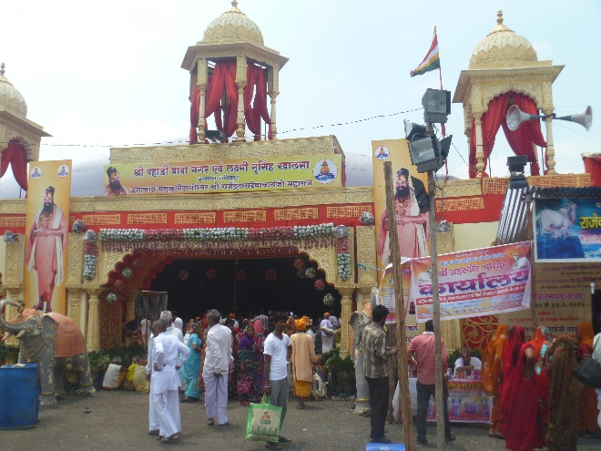

One of many tents along “Sadhu Row” These tents hold hundreds of worshipers and Victoria was severely chastised for bring an egg into the vicinity.

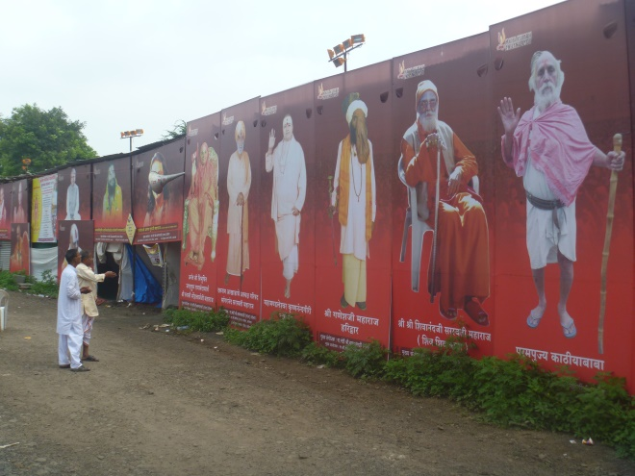

Advertising sadhus

What I couldn’t figure out was who awards rankings as there is an obvious pecking order that is followed

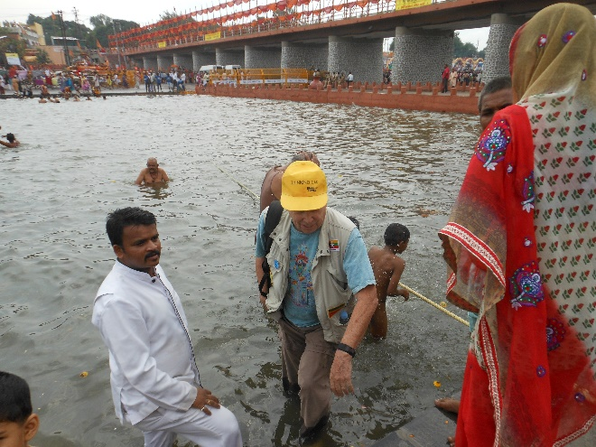

My sins go away as well

Now looking for new ones

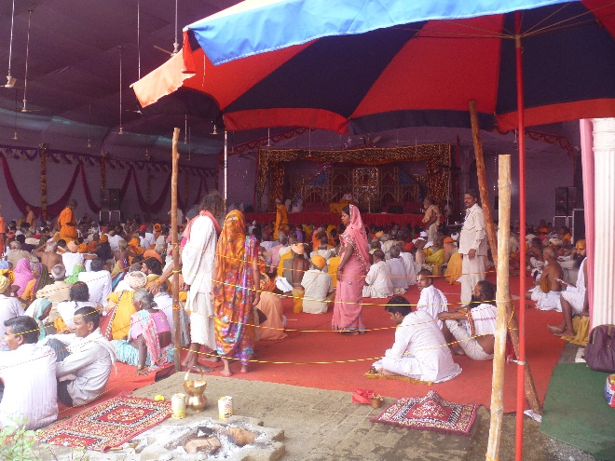

This is the tent of one of the major sadhus. There were many of them capable of holding hundreds of people. The set up was very much large a large carnival complete with competing signs and barkers to attract a following.

Note Victoria got into trouble for bringing an egg into the area. Some guy went high order but she was just intending to give it to some hungry person.

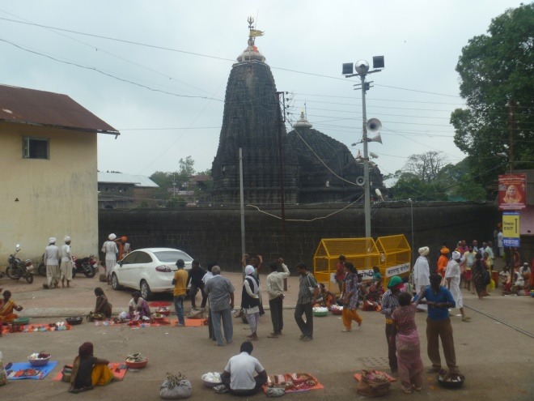

This is Trimbakeshwar (jyotirlinga), the main temple located about 45 minutes from Nashik. It was closed for the time we were there due to overwhelming crowds who still wanted to bathe at the sacred site.

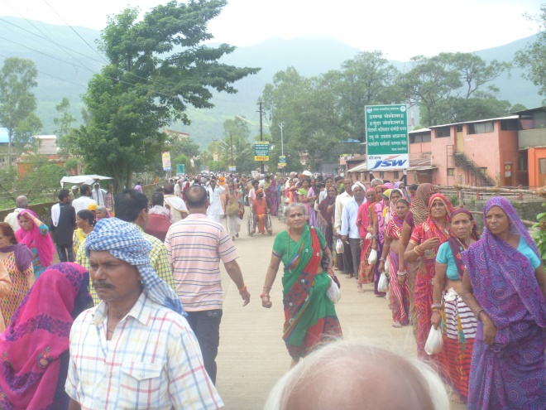

That line is some of the 12,000 people waiting for a quick dip. Each waited many hours for their turn. The following day a very heavy rainstorm hit in the late afternoon but it did not dissuade the pilgrims at all.

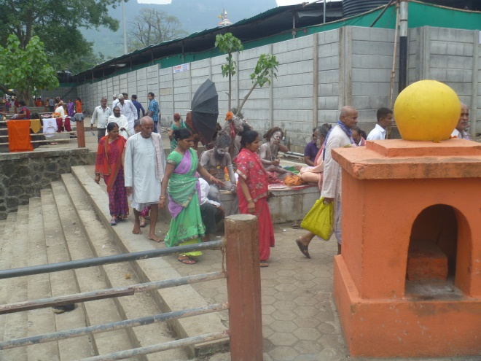

Here are few of the naked sadhus who wander about the country without any clothes. There is no big fuss about their lack of dress and they are generally ignored.

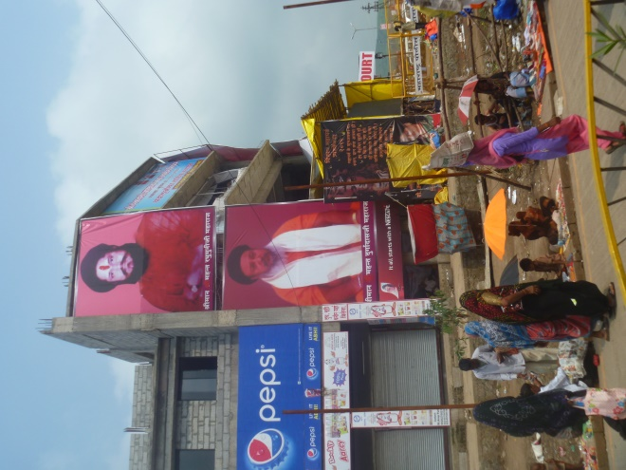

Note the size of the ads for the top sadhus. Who creates all this stuff? Some would do Madison Avenue proud.

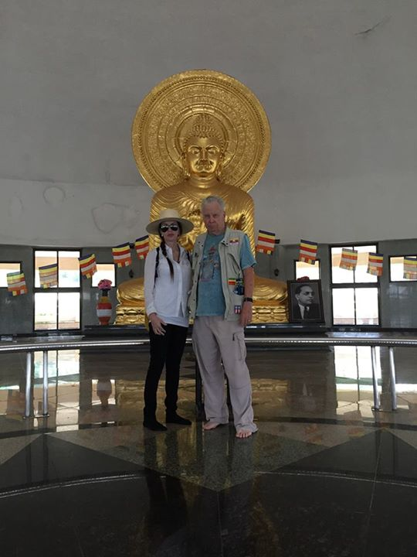

Multicultural, this is a Buddhist statue is in the Dadasaheb Phalke Memorial. It is named after the founder of the Indian film industry.

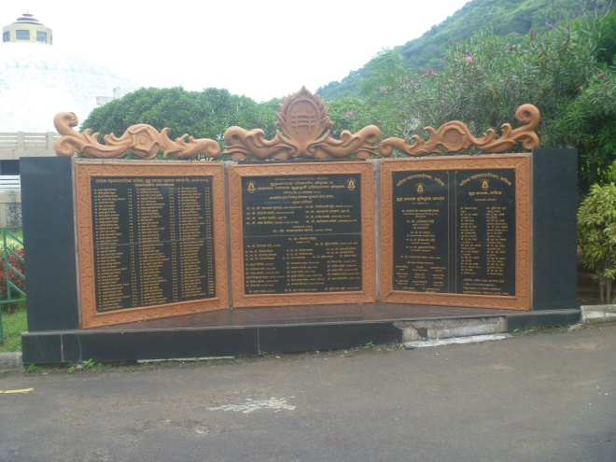

As is explained on this sign. The memorial is located at the base entrance to the Pandu Lena Caves which are a few hundred feet up the hill side. The caves were carved out from the 4th century BC till the 12th century AD as abodes for the idols of the local kings. The caves lodge idols of Buddha and Bodhisattva. Some caves are intricately connected by stone-cut ladders that join them to the other caves.

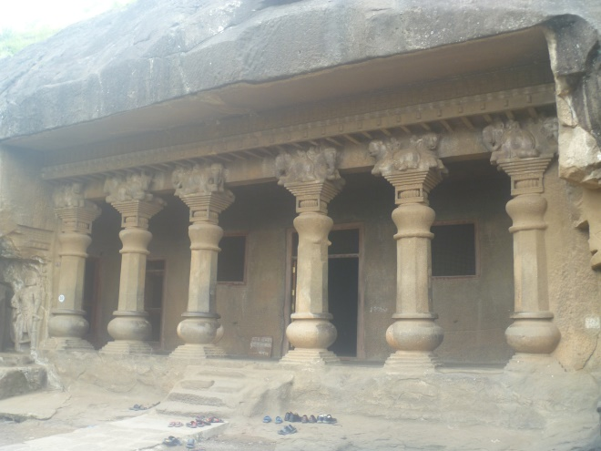

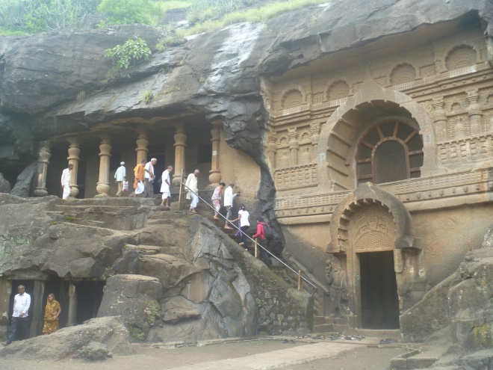

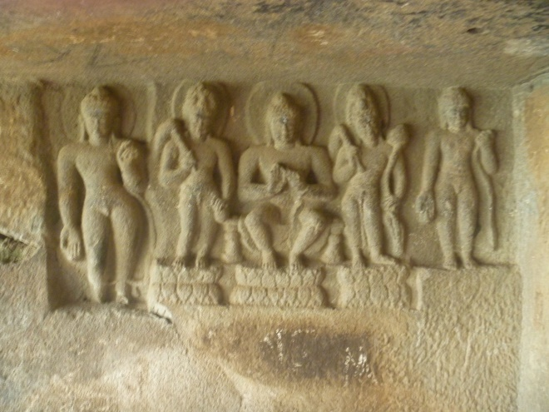

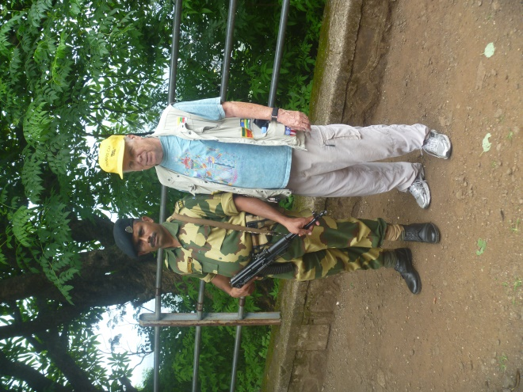

The caves were the first site at which we found military guards.

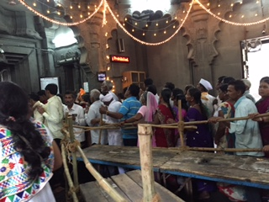

Muktidham is a marble temple complex honoring various Hindu gods. Long line to get in but I did jump up and ring the bell at the entrance. That seemed to delight the locals and we did not see any other round-eyes at this site (and very few elsewhere)

To the right are women praying for fertility at Shree Ved Temple. Not sure why the turtle was significant.

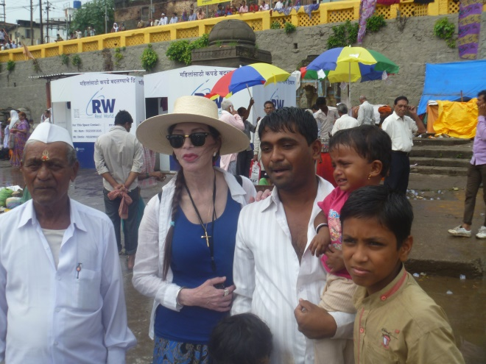

People often asked to have their photo taken with obvious foreigners. We even were offered babies to hold.

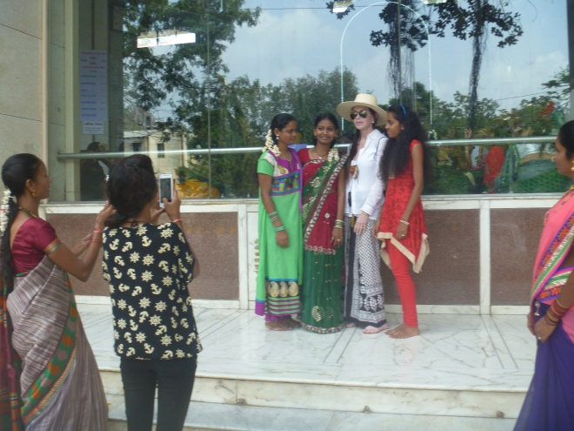

Victoria with young girls photo op at Shree Ved Temple

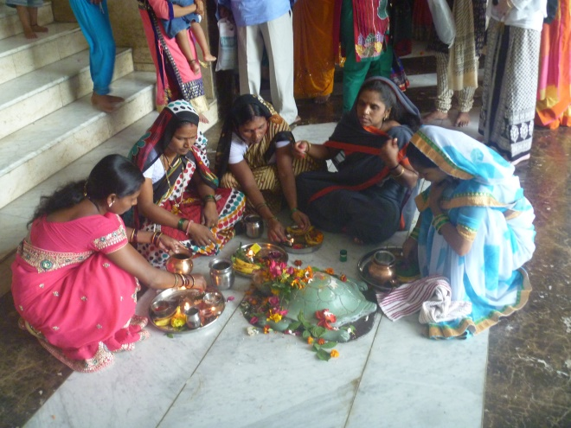

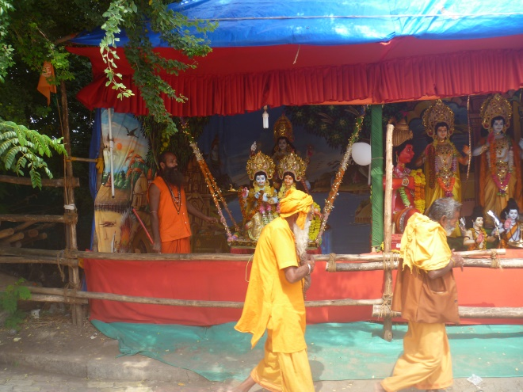

Visiting Sadhu Row – an area of temporary camps and halls for pilgrims

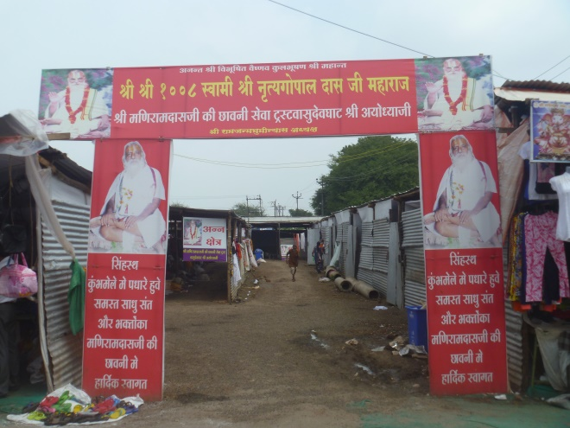

Sadhus passing Victoria – there were thousands of them in Nashik

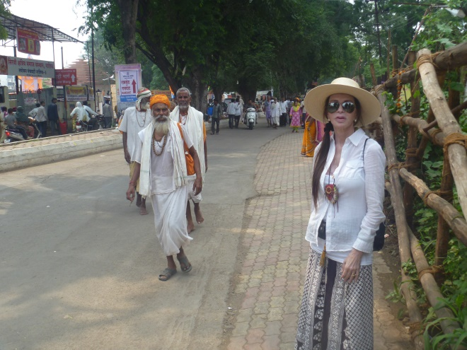

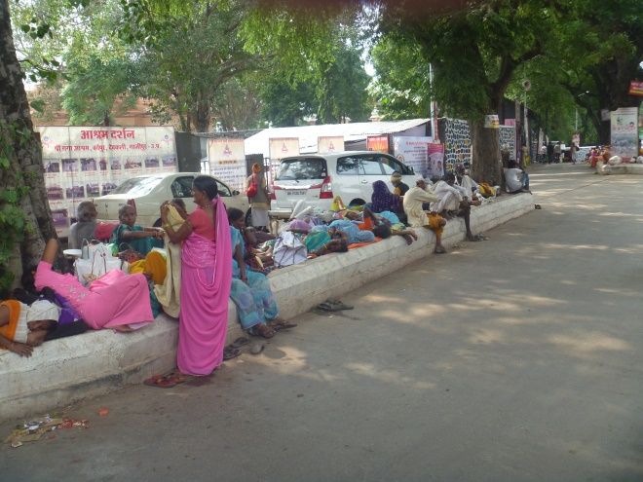

Many were sleeping in the road dividers in the middle of the day

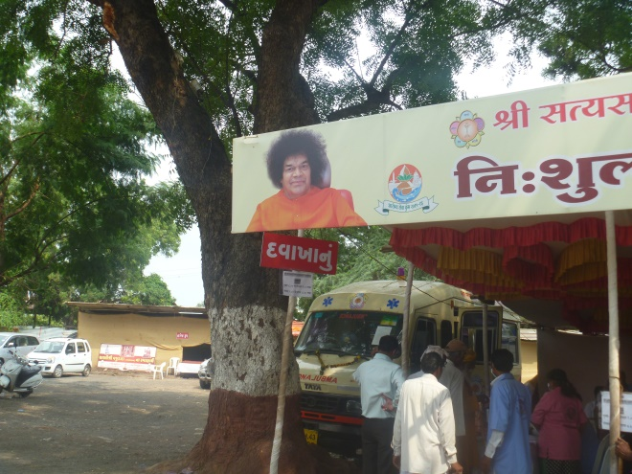

Sathya Sai Baba is still present - at least in spirit (he died 2011)

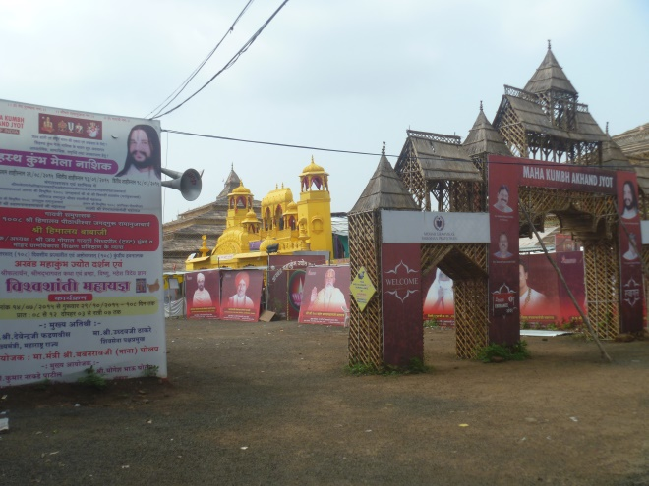

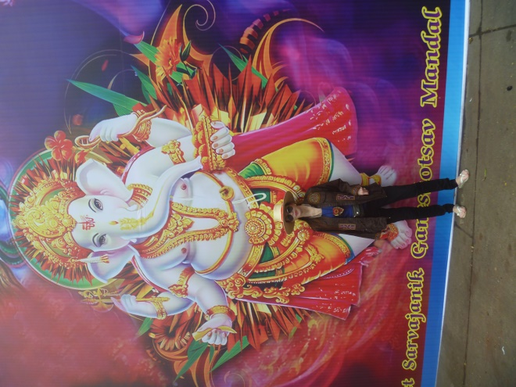

We arrived back in Mumbai just in time for the festival for the Hindu god Ganesh. Notably, Ganesh is also affiliated with Buddhists and Jains. Ganesh's elephant head makes him easy to identify. Ganesh is widely revered as the remover of obstacles, the patron of arts and sciences and the deva of intellect and wisdom. As the god of beginnings, he is honored at the start of rituals and ceremonies. Ganesh is also invoked as patron of letters and learning during writing sessions.

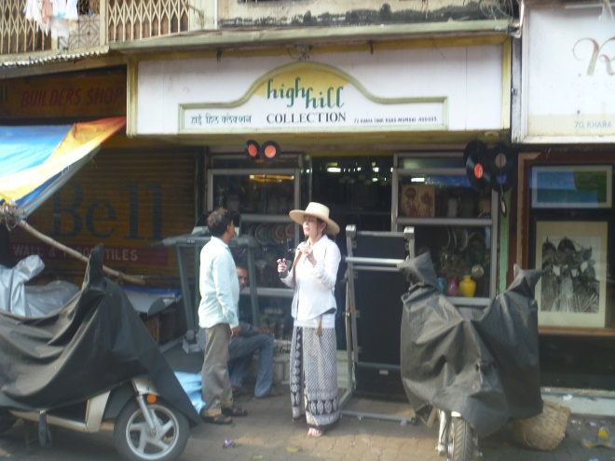

The Chor Bazaar shopping area was not what we expected. Shops were dirty and mostly sold mechanical parts for appliances.

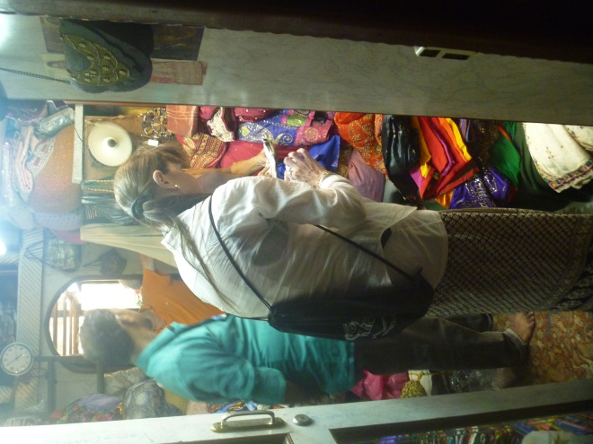

Victoria negotiating. This shop was on the second floor entered only by going down a dark alley and upstairs. The owner supplies clothing stores, and he is not usually selling to individuals, let alone foreigners. Really wondered what we were doing here. The room next door was under construction and had live goats in it.

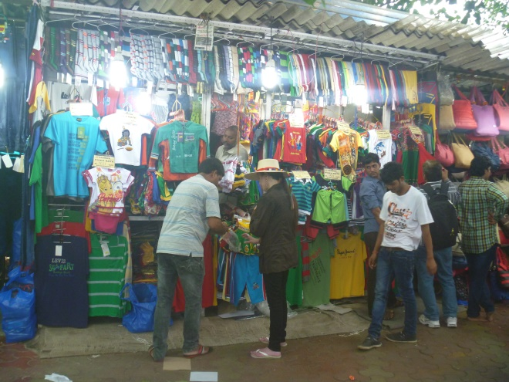

Saw many street vendors but the vast majority were selling Western style clothes.

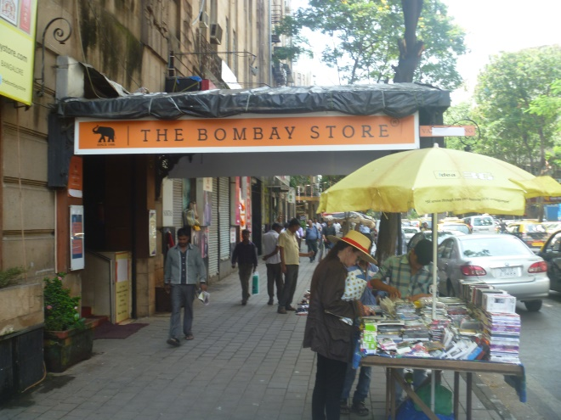

Many do refer to this as Bombay, the old British name for the densely populated city which is home to an estimated 22 million people.

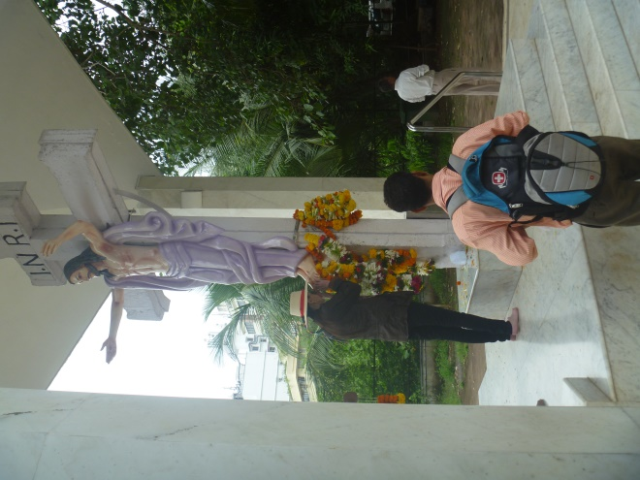

Surprisingly, we did find a Christian monument located in a major park area

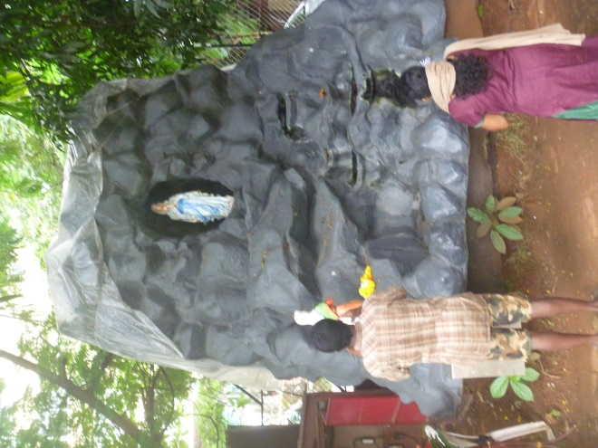

It came with a grotto with a BVM statue

**A final word of caution!!!**

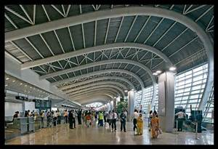

The Mumbai airport is ultramodern but there is a huge problem! While going through security (their TSA equivalent) we were robbed by the security personnel. Obviously coordinated, the person screening handbags alerted an accomplice who removed an item from my bag. This was done while I was being physically patted down. They inserted a bottle of water so as the weight differential would not be noticed. That was found by TSA at JFK. When the airport operators were notified, they did nothing and did not even respond.